Student Performance Tracker
Project Report



Submitted By : Swarnima Sah
25BAI10597

- This report is submitted as part of the Flipped Classroom Project requirements
under the School of Computing Science and Engineering
VIT Bhopal.

INTRODUCTION

The Student Performance Tracker is a Python-based console application designed to simplify the process of recording student marks and evaluating their academic performance. Traditional manual systems such as handwritten notes or spreadsheets often become messy, time-consuming, and prone to errors. This project aims to provide a simple and efficient digital solution for maintaining student data.

The system allows users to add student information, record marks, calculate averages, and view reports in a clear and organized format. It is built using Object-Oriented Programming (OOP) principles and follows a modular structure with separate Python files for student details, storage management, and user interactions. This makes the project easy to understand, maintain, and expand.

PROBLEM STATEMENT

Teachers, tutors, and students often face difficulties managing academic records when using manual or unstructured methods. Problems such as missing information, calculation mistakes, difficulty searching records, and lack of centralized storage make performance tracking inefficient.

There is a need for a simple digital application that can:
- Store student details safely
- Add marks for multiple assessments
- Automatically compute average performance
- Display student-wise and class-wise details
- Reduce manual errors and save time
This project solves these problems by creating a lightweight, easy-to-use Python application that eliminates manual bookkeeping and streamlines student performance tracking.

FUNCTIONAL REQUIREMENTS

1. Add Student
The system must allow adding a student using ID and name.

2. Add Marks
Users must be able to enter marks for any existing student.

3. View Student Performance
System must display marks and average score for a selected student.

4. View All Students
System should list all students along with their marks and averages
5. Menu-Driven Interface
The system must provide a simple numbered menu for all operations.

6. In-memory Data Storage
Student data must be stored temporarily using Python dictionaries.

NON-FUNCTIONAL REQUIREMENTS

1. Usability
The system should be easy to use, even for non-technical users.

2. Performance
Operations such as adding students or viewing data must be fast.

3. Reliability
The system should work without crashing or losing data during runtime.

4. Maintainability
Code should be modular, readable, and easy to extend.

5. Portability
Should run on Windows, macOS, and Linux with Python installed.

6. Security
Since data is temporary, security requirements are minimal, but the program should not expose sensitive inputs.

SYSTEM ARCHITECTURE

The system follows a three-module architecture:

1. student.py
Contains Student class storing ID, name, and marks.

2. storage.py
Contains Storage class which manages all student objects.

3. performance.py
Main program that interacts with the user and displays

DESIGN DIAGRAMS

- USE CASE DIAGRAM


ADD MARKS

EXIT SYSTEM
ADD STUDENT
VIEW STUDENT PERFORMANCECE
VIEW ALL
STUDENTS

- WORKFLOW DIAGRAM
START

DISPLAY MENU

USER SELECTS
OPTION

STOP
ADD STUDENT
CHOICE
EXIT

VIEW ALL STUDENTS
ADD MARKS
VIEW STUDENTS

3.SEQUENCE DIAGRAM
student.py
storage.py
Performance.py
USER

4. CLASS DIAGRAM
STUDENT
-student_id
- name
-marks
+ add marks()
+ average

STORAGE
- student{}
+ add_student()
+ add_marks()
+ show_all()

5. ER DIAGRAM
STUDENT
marks
student_id
(Primary Key)

name

DESIGN DECISIONS & RATIONALE

OOP Approach:
Using classes (Student, Storage) keeps the code organized and makes the system easy to extend.

Dictionary Storage:
Student records are stored in a Python dictionary for quick access using student ID.

Modular Files:
Code is divided into 3 files (student.py, storage.py, performance.py) to keep logic clear and maintainable.

Simple Console Menu:
A menu-driven interface was chosen to make the system easy to use without needing extra libraries.

No External Libraries:
Keeps the project lightweight and ensures it runs on any system with Python installed.

IMPLEMENTATION DETAILS

student.py:
Contains the Student class, which stores ID, name, marks, and calculates average marks.

storage.py:
Contains the Storage class, which manages all student objects using a dictionary.

performance.py:
The main program. Displays options, takes user inputs, and calls functions from Storage.

Basic Flow:
User → Menu → Storage → Student → Output to User

SCREENSHOTS / RESULTS
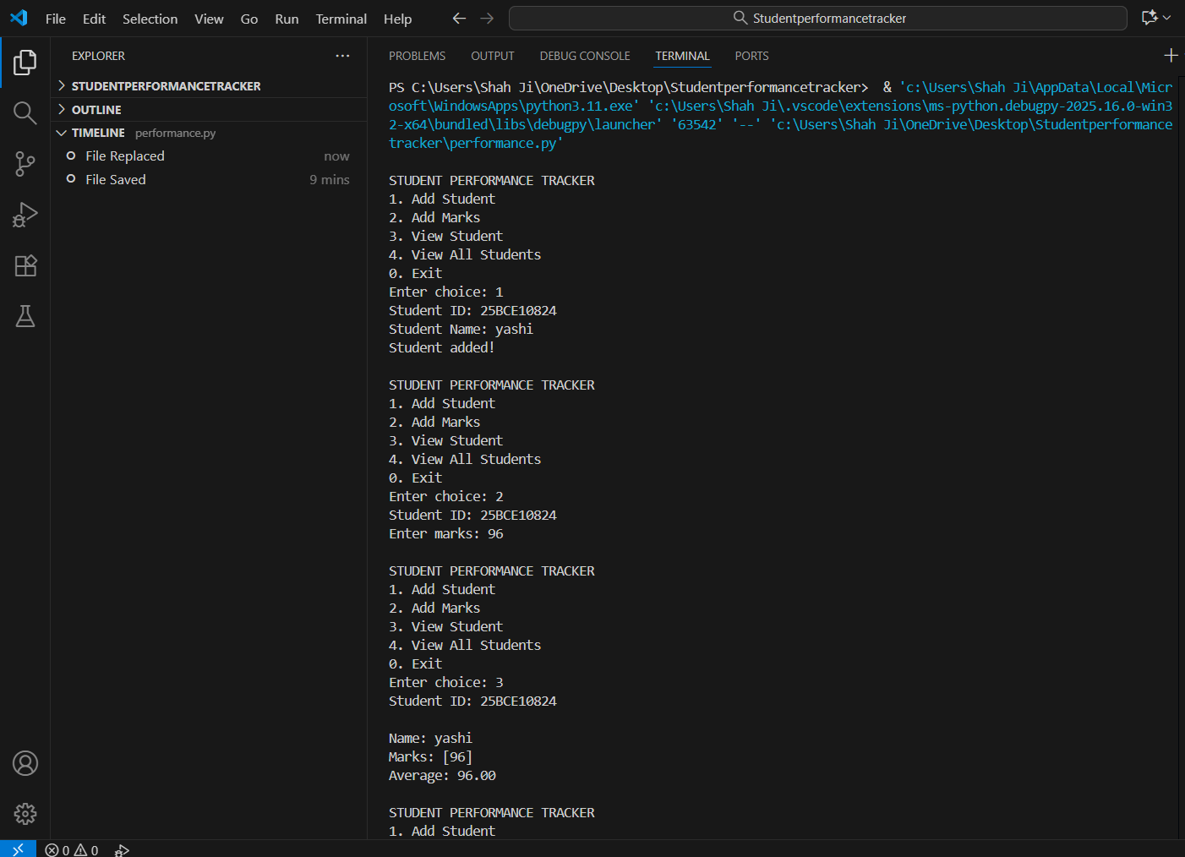
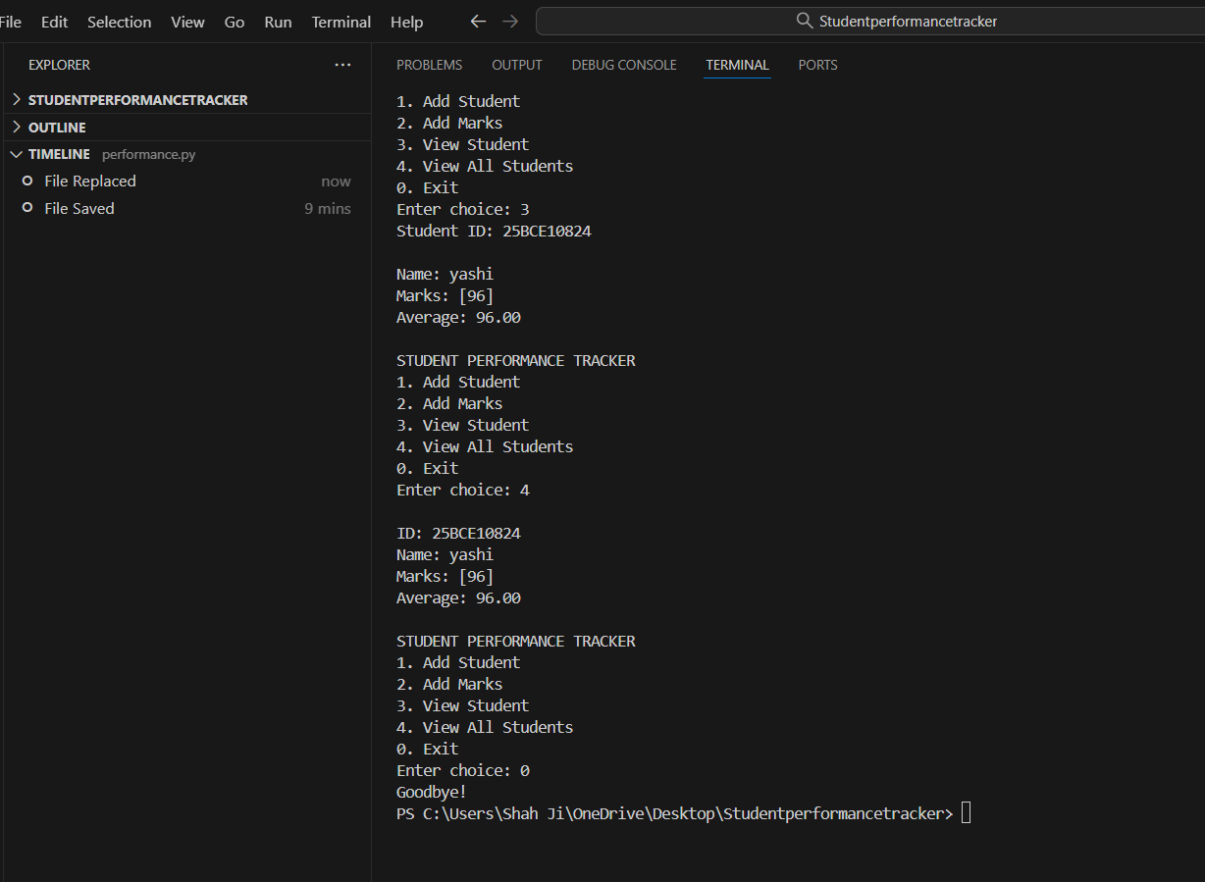

TESTING APPROACH

Function Testing: Checked add_student(), add_marks(), and average() individually.

Integration Testing: Verified that all files work together without errors.

Input Testing: Tried invalid inputs like wrong student ID or wrong data types.

Manual Testing: Used the program multiple times with different inputs.

All tests showed correct results.

CHALLENGES FACED

Import errors when managing multiple Python files

Indentation mistakes in Python

Handling cases when a user enters an invalid student ID

LEARNINGS & KEY TAKEAWAYS
These challenges improved debugging and logic-building skills.

Better understanding of classes and objects

How to organize code into multiple files

Learned how to design a simple menu-driven application

FUTURE ENHANCEMENTS

Add file/database storage so data is saved permanently

Add editing and deleting of student records

Add ranking or grade calculation

REFERENCES

Python Documentation
Tutorials Point Python
VIT Project Guidelines PDF

